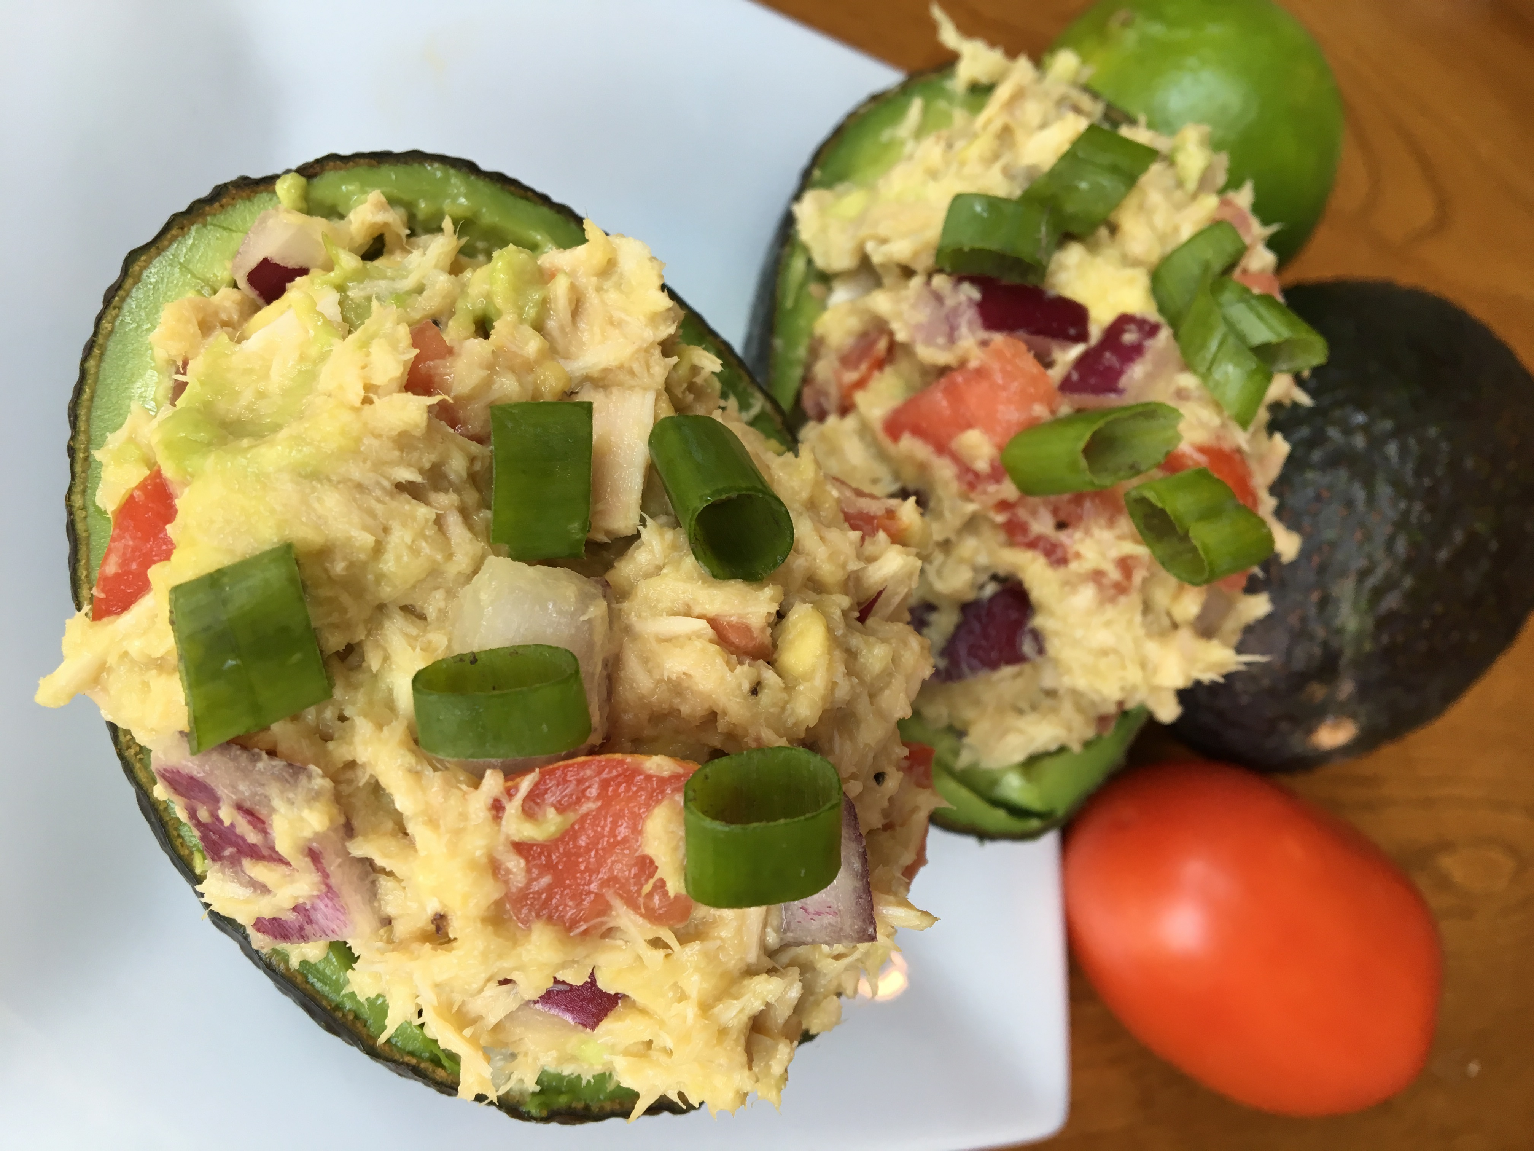

 **Avocado Tuna Salad**

*Serves 2*

**Ingredients**

1 Avocado

1 can Tuna

1 Roma tomato, chopped

¼ cup diced red onion

1 lime, juiced

Salt and pepper

**Directions**

1. Cut the avocado in half and remove the pit. Scoop out most of the avocado and place in a bowl. Leave a thin layer in the avocado.
2. Add tuna to bowl and mash together with a fork. Add tomato, onion, lime juice, salt, and pepper. Mix well.
3. Spoon half of the mixture into each avocado skin.
4. Serve with a side salad!

**Nutrition**

*160 cals, 6g C, 14g P, 14g F*