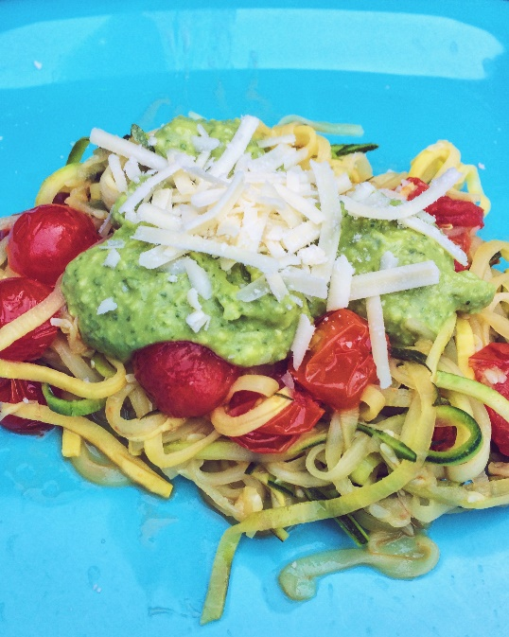

 **Zucchini Noodles with Avocado Pesto**

*Serves 5-6 (depending on the size of the zucchinis)*

**Ingredients**

1 container of cherry tomatoes

Optional: grated parmesan cheese to sprinkle on top

Oil for the pan

For the Sauce:

2 avocados

¼ cup olive oil

1.5 cups of basil

¼ cup pine nuts

2 garlic gloves

Pinch of salt

Pinch of pepper

Tools needed:

Spiralizer or peeler

* Spiralizers can be bought for under $15 at grocery stores and bed bath and beyond. Peelers work too but are much more time consuming than spiralizers.

**Directions**

1. Use a spiralizer or peeler to make zucchini noodles. Place them in a colliders in the sink to allow extra water to drain.
2. Meanwhile, cut cherry tomatoes in half.
3. Blend the sauce ingredients in a food processor.
4. Cook the zucchini noodles and cherry tomatoes in a large pan for about 5 minutes or until tender.
5. Serve the zucchini noodles with the avocado pesto sauce and a sprinkle of grated parmesan cheese. Eat with your choice of protein on the side.

**Nutrition**

260 cals, 8g C, 6g P, 26g F