** Cauliflower Mash**

***Serves 4***

**Ingredients**

Florets from 1 large head of Cauliflower

¼ cup unsweetened almond milk or regular milk

Salt, to taste

Pepper, to taste,

1-2 dashes of nutmeg

Optional: 2 tbsp. of butter

**Directions**

1. Steam cauliflower florets until tender.
2. Transfer florets to a large bowl and add almond milk, salt, pepper and nutmeg and optional butter. Mash until smooth.

**Nutrition**

Per serving: 41 Cals, 4 C, 3g P, 1g F

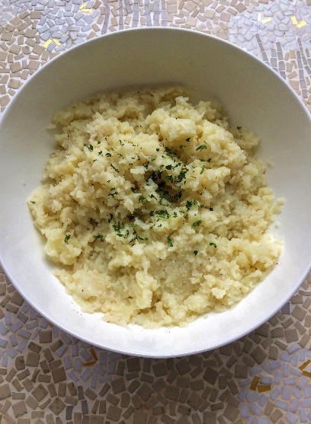

p