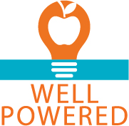 **Spaghetti Squash Alfredo**

*Serves 4*

**Ingredients**

1 cup spaghetti squash

¼ Greek Yogurt Alfredo recipe

½ cup cook broccoli

2 Turkey Meatballs

**Directions**

1. Heat skillet on medium. Add spaghetti squash, alfredo, cooked broccoli, and meatballs. Cook until heated through.
2. If sauce is thick, add a little more milk or water.

**Nutrition**

*325 cals, 18g carb, 24g protein, 17g fat*