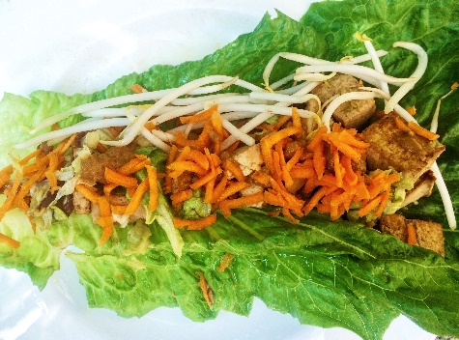

 **Asian Tofu Wraps**

*Serves 2*

**Ingredients**

1 head of romaine lettuce

1 package extra firm or extra firm tofu

1 cup shredded carrots

1 white cabbage, sliced into thin shreds

50g bean sprouts

125g shitake mushrooms, sliced

Oil for cooking the tofu (vegetable oil or sesame oil)

Tofu Marinade:

8 tsp soy sauce

1 tsp ground coriander

2 tsp ground ginger

Juice from ½ lime

½ tsp apple cider vinegar

Peanut Dipping sauce:

1.5 tbsp crunchy peanut butter (or 1 tbsp smooth peanut butter with 1 tbsp roasted peanuts)

2 tsp soy sauce

½ lime juice

Meat Option: use 1lbs of shrimp instead of tofu. Use the same marinade and cook in a large skillet as well.

**Directions**

1. Wash romaine lettuce leaves.
2. Assemble the tofu marinade and peanut dipping sauce.
3. Cut the tofu into 2 pieces and place in between 2 kitchen or paper towels and press down with a plate or cutting board to drain water out of the tofu. Then cut the tofu into 1 inch pieces. Add the tofu pieces to the marinade, ensuring they are all covered. Let stand for a few minutes
4. Heat oil in a large frying pan and add the tofu pieces and remaining marinade. Cook about 5 minutes until the first side in golden brown. Meanwhile, chop the cabbage into thin shreds and the mushrooms into thin slices. Either cut the carrots into thin sticks or use a food processor.
5. Flip the tofu pieces over to the other side and cook for about 2 minutes. Then add the mushrooms and cabbage. For about 3 minutes or until the cabbage has wilted
6. Assemble your wraps by placing the tofu, cabbage, mushrooms, carrots and beansprouts all together. Top with the peanut dipping sauce.

**Nutrition**

381 cals, 16g C, 31g P, 17g F