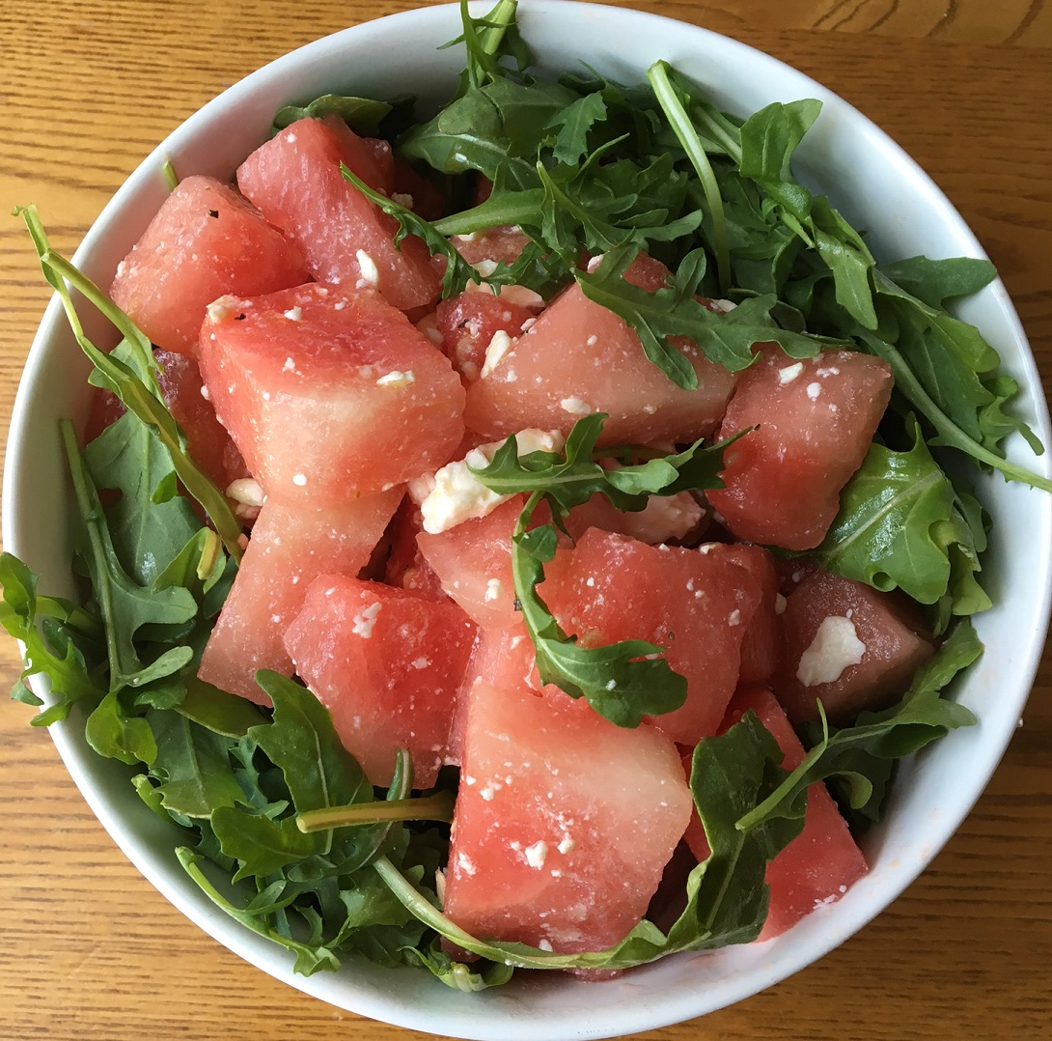

 **Watermelon Feta Salad**

*Serves 12*

**Ingredients**

1 8lb watermelon

¼ cup olive oil

3 limes, juiced

1 tsp salt

½ tsp pepper

1 cup mint leaves, chopped

1 ½ cup crumbled feta

1 bunch arugula

**Directions**

1. Cut watermelon into 1 inch chunks
2. Whisk together olive oil, lime juice, salt, and pepper in a small bowl.
3. Add watermelon and mint to a large bowl. Pour dressing into the bowl and mix together. Toss in feta cheese.
4. Serve salad over bed of arugula. Enjoy as a side dish with a protein and veggies!

**Nutrition**

*175 calories, 22g C, 9g F, 4g P*